Institute of Technology, Nirma University
Semester V

Course Code & Name: 3CS103ME24
Data Analysis and Visualization

Topic: “Food_Delivery_Time_Prediction”

Submitted By:
Princy Pandya 23BCE207
Yamini Pambhar 23BCE204



School of Engineering
Institute of Technology
Nirma University
Ahmedabad-382481

September 2025
Domain Selected: Urban food delivery logistics, predictive analytics, and service optimization.

Introduction
As a team, we investigated the core problem of predicting and analyzing food delivery times for urban and suburban environments. The reliability of food delivery is a decisive factor in customer satisfaction and operational efficiency. Through data exploration and plotting, we aimed to uncover the variables that most affect delivery duration and offer actionable insights for stakeholders, including platform operators, delivery partners, customers, and data scientists.

Objectives of the Study
- Develop a robust method to predict food delivery time using historical data.
- Analyze the influence of factors such as weather, traffic, location, ratings, cost, priority, and experience on delivery performance.
- Identify system bottlenecks and provide recommendations for improved efficiency.
- Assist all stakeholders in decision-making through data-driven findings and visual evidence.

Raw Data Structure: Description and Sample Content
This raw dataset includes the following columns for each order:

Feature | Description
Order_ID | Unique identifier for each delivery
Customer_Location | Latitude and longitude coordinates of customer address
Restaurant_Location | Latitude and longitude coordinates of restaurant
Distance | Calculated distance between restaurant and customer
Weather_Conditions | Weather status during delivery (e.g. Rainy, Cloudy, Snowy)
Traffic_Conditions | Traffic level (e.g. Low, Medium, High)
Delivery_Person_Experience | Years/months of delivery person's experience
Order_Priority | Order urgency class (e.g. Low, Medium, High)
Order_Time | Time of day order was made (e.g. Morning, Afternoon, Evening, Night)
Vehicle_Type | Delivery vehicle type (e.g. Bike, Car, Bicycle)
Restaurant_Rating | Restaurant's quality rating
Customer_Rating | Customer's rating
Delivery_Time | Recorded delivery time (target variable)
Order_Cost | Total cost of the order
Tip_Amount | Tip paid by customer

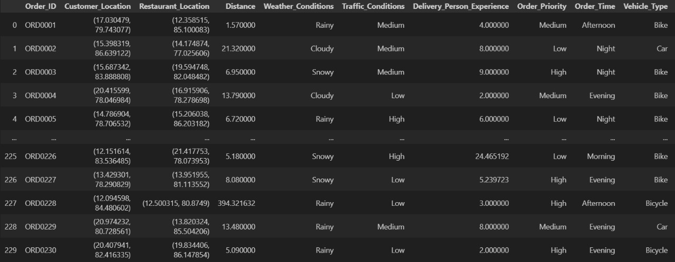
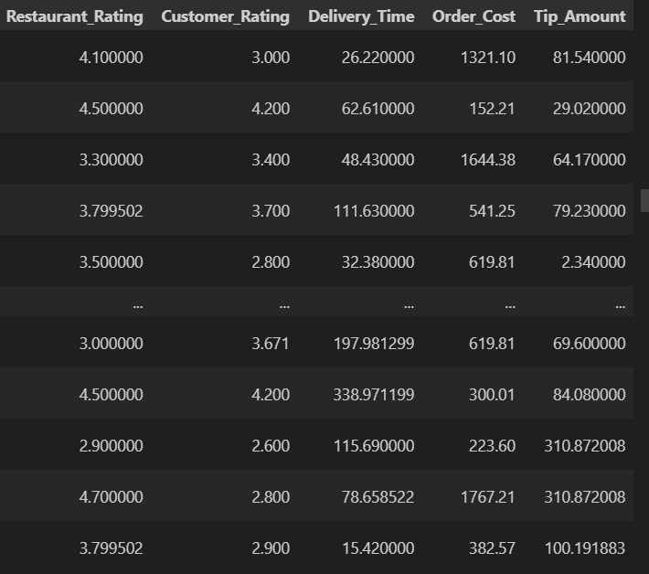

How the Dataset Supports Our Project
The row-level structure allows us to:
- Visualize and compare deliveries based on traffic, weather, and priority.
- Map out spatial trends using location data.
- Quantify how rating, tip, experience, and vehicle choice influence delivery outcomes.
- Identify operational inefficiencies and potential improvements for all stakeholders.

Scope and Stakeholders
Scope
Our study analyzed real-world food delivery transactions covering customer and restaurant locations (geocoded), weather and traffic conditions, delivery person experience, order priority, vehicle type, ratings, time, order cost, tip amount, and the resulting delivery time. We processed and cleaned the data to ensure validity and conducted extensive exploratory data analysis through KNIME and Python.
Stakeholders
Stakeholder | Key Needs Addressed
Customers | Reliable and transparent expected delivery times; factors affecting delay
Delivery Partners | Efficient routes, fair workload, optimal vehicle and time selection
Restaurants | Pickup coordination, rating’s impact on delivery timeliness
Platform Managers | Delay bottleneck diagnosis, systemwide optimization strategies
Customer Service | Advanced warning of potential delays, targeted support for problematic orders
Data Science Teams | High-quality features for modeling, robust diagnostics and outlier management
Local Regulators | Understanding of traffic/weather impact on delivery safety and timing

Data Characteristics
We thoroughly analyzed the dataset structure and summary statistics using both KNIME and direct inspection. Distinct column types, value ranges, and distributions are listed below.
Column | Type | Distinct Count | Min | Max | Mean | Std. Dev
Distance | Float | 190 | -50.08 | 73.07 | 11.29 | 12.39
Weather_Condition | String | 4 | - | - | - | -
Traffic_Condition | String | 3 | - | - | - | -
Delivery_Person_Experience | Float | 15 | -19.45 | 24.47 | 4.95 | 3.77
Order_Priority | String | 3 | - | - | - | -
Order_Time | String | 4 | - | - | - | -
Vehicle_Type | String | 3 | - | - | - | -
Restaurant_Rating | Float | 27 | 2.5 | 5.0 | 3.80 | 0.68
Customer_Rating | Float | 26 | 2.6 | 5.0 | 3.68 | 0.67
Delivery_Time | Float | 200 | -197.98 | 338.97 | 65.48 | 56.58
Order_Cost | Float | 196 | -3890.63 | 5983.61 | 1011.73 | 1016.33
Tip_Amount | Float | 189 | -217.64 | 310.87 | 46.39 | 44.17

Exploratory Plots and Group Observations
1. Scatter Plot: Delivery Time vs. Distance
We plotted delivery time against delivery distance and observed that most records are within a realistic range, but outliers do exist — particularly negative values, which need careful attention before modeling. There is an expected positive relationship but not a strictly linear pattern.
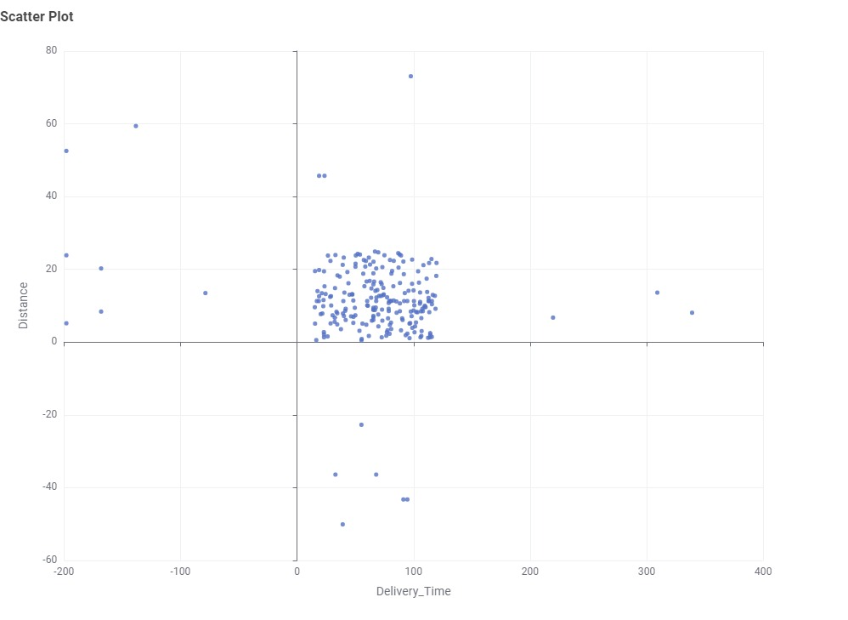

2. Histogram: Distribution of Delivery Time
Histogram analysis showed that most deliveries are completed within 40–120 minutes, with a tail on both ends and some negative values, which reflect potential data entry or system issues.
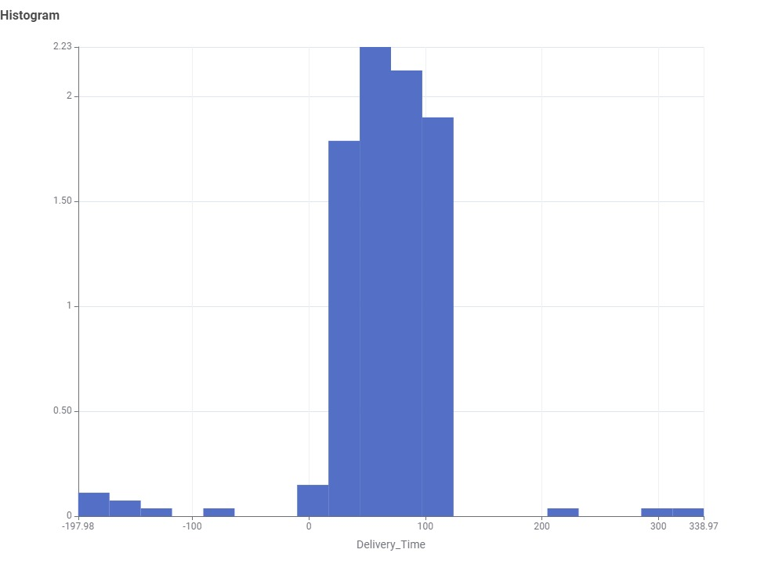

3. Histogram: Order Cost
The majority of orders cost between 500 and 2000 units, with some low and even negative values potentially indicating refunds or cancellations.
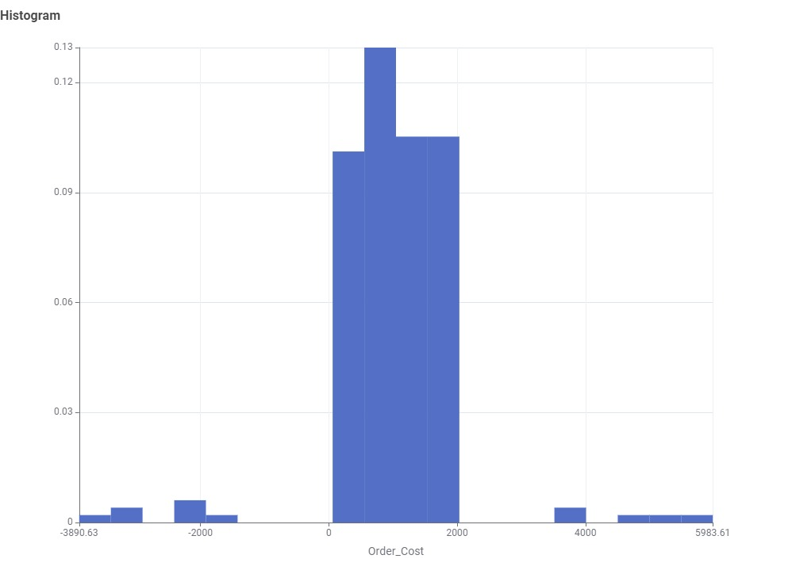

4. Boxplot: Delivery Time by Traffic Conditions
Higher traffic conditions generally result in longer and more variable delivery times, with notable outliers in both low and high traffic groups, indicating unpredictability and a clear impact of traffic congestion on delivery efficiency.
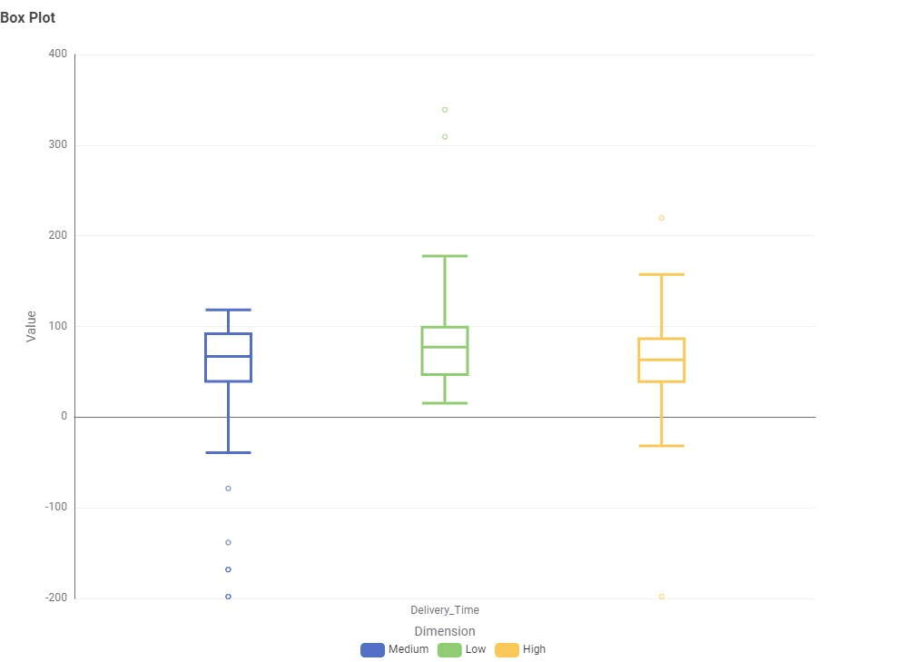

5. Boxplot: Delivery Time by Vehicle Type
Bikes, cars, and bicycles result in similar median delivery durations, but the variability is higher for bikes, likely due to route/delivery partner differences.
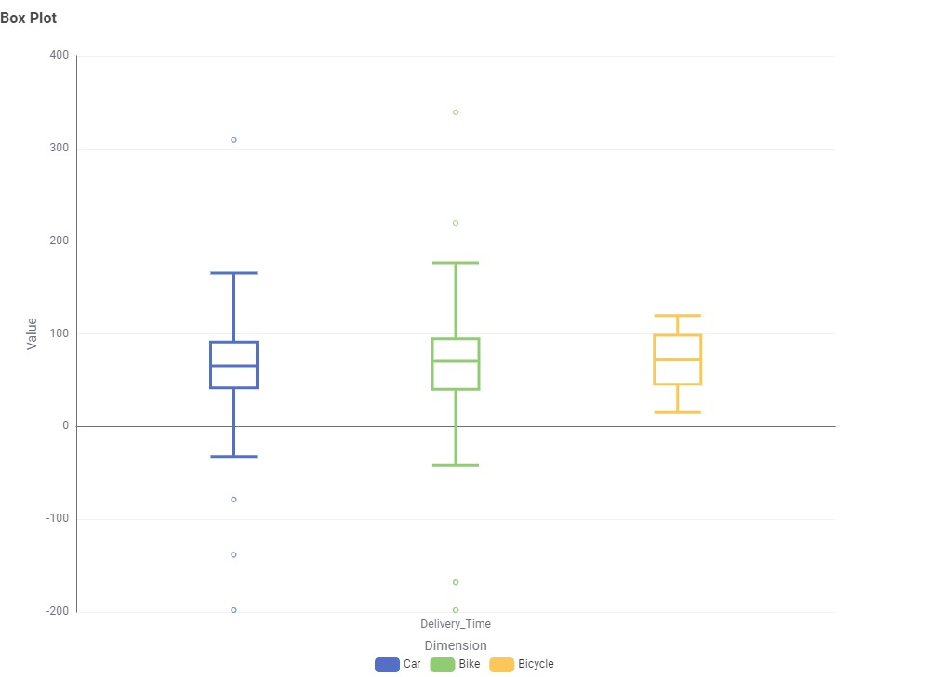

6. Correlation Matrix: Numeric Features
Most feature pairs showed weak or negligible correlation, as visualized in our heatmap. Customer rating and delivery time had a minor negative correlation, perhaps indicating that fast service improves feedback.
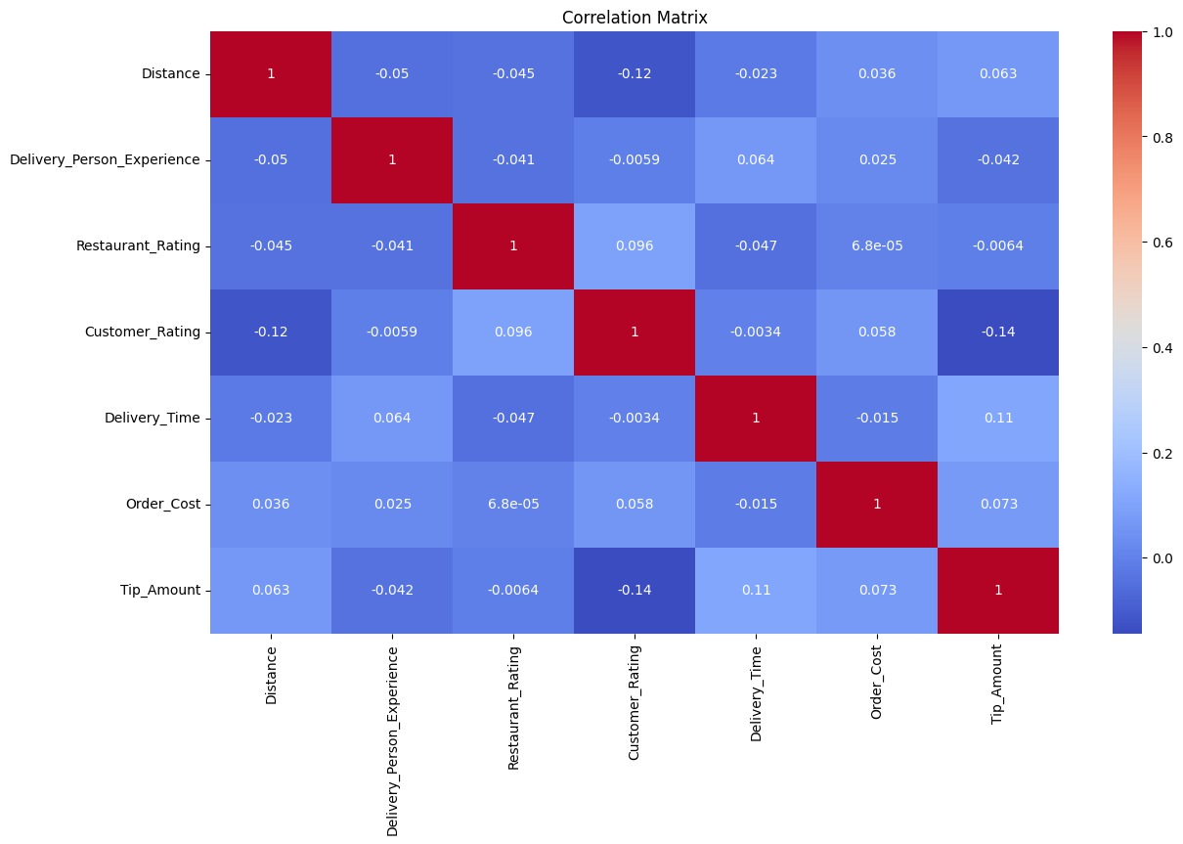

7. Histogram: Tip Amount
Tips are clustered between 20 and 100 units, with negative and high outlier values possibly due to corrections or rare events.
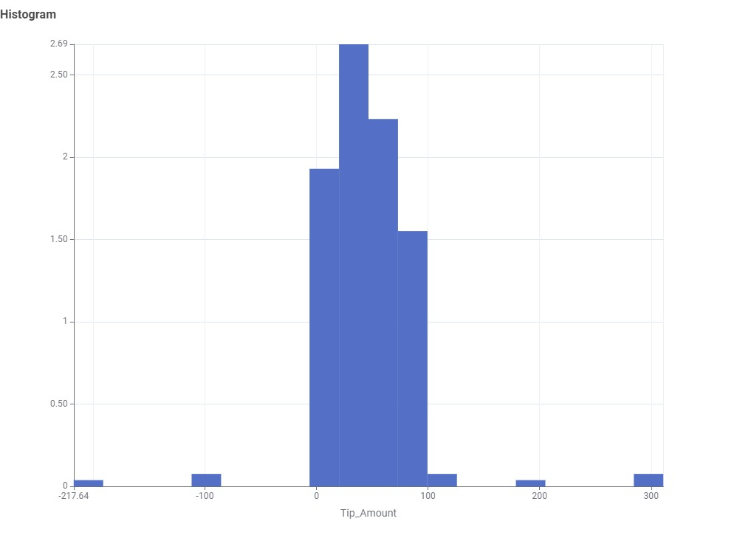

8. Boxplot: Delivery Time by Weather Condition
We found that adverse weather, especially rain and snow, increases both median delivery times and the spread of values. Sunny and cloudy weather correlated with quicker, more consistent deliveries.
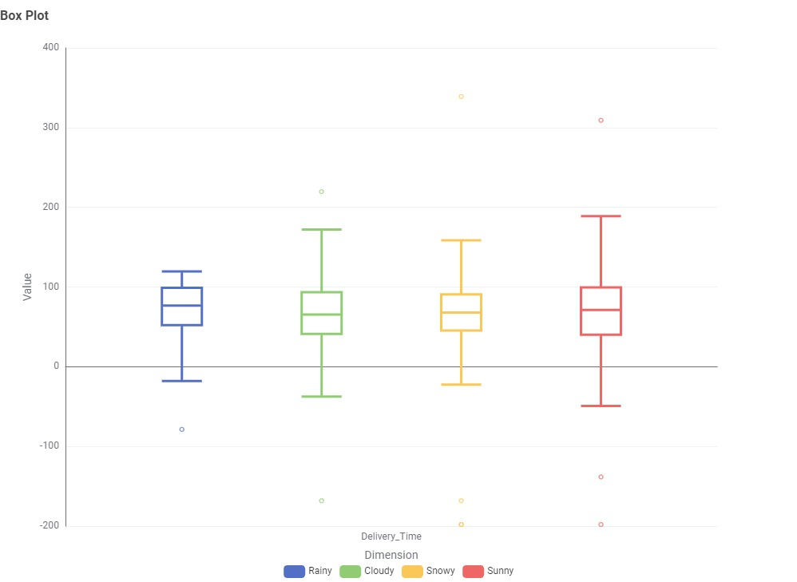

9. Distribution Table: IQR & Outlier Boundaries
Our IQR analysis of all numeric columns revealed significant spread and a non-trivial presence of outlier values. This highlights a need for careful preprocessing of anomalous entries for model training.
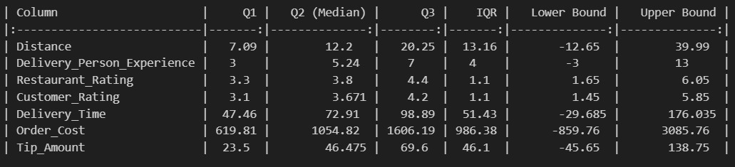
10. Barplot: Delivery Time by Order Priority
This plot visually confirmed that order priority does, on average, reduce delivery time, although high variability persists within all priority bands.
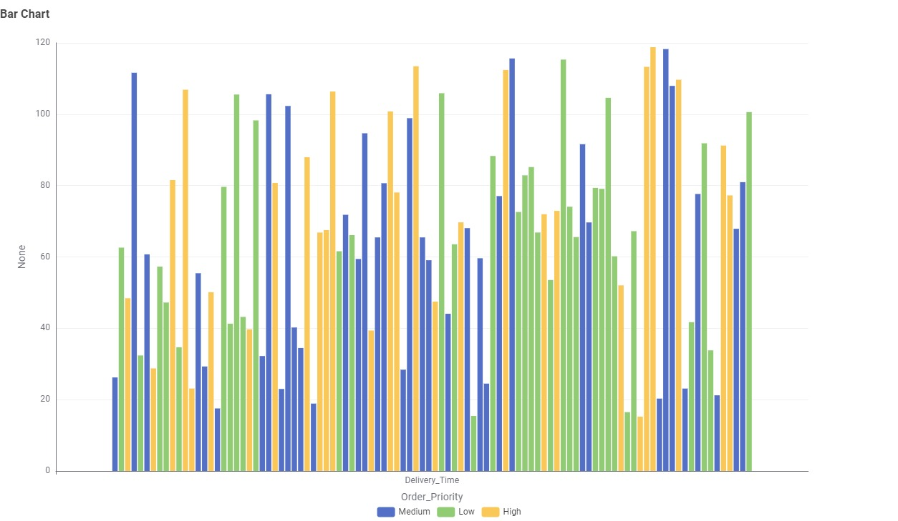

11. Geographic Scatter Plot of Deliveries
We generated a geographic scatter plot using Python, presenting both customer and restaurant locations. We observed that deliveries are widely distributed throughout the region, with no strong visual clustering in a particular zone, highlighting broad market activity.
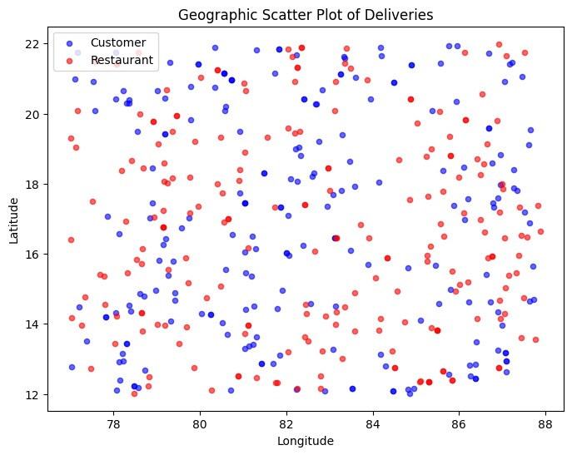

12. Hexbin Density Plot of Deliveries
Our hexbin plot of customer delivery coordinates revealed some local density clusters, indicating hotspots of activity or frequent delivery locations. These could guide resource allocation or marketing efforts.


Challenges & Recommendations
- We found that some location-based exploratory plots cannot be generated in KNIME; we recommend exporting latitude/longitude columns to Python (as demonstrated above), Tableau, or Power BI for deeper spatial analysis.
- Outliers and negative values in key columns (delivery time, distance, cost, tips) need to be handled before advanced modeling.
- The generally low correlations and high IQR (interquartile ranges) suggest non-linear and interacting effects among features; more advanced feature engineering should be tested in future ML model runs.

Stakeholder Questionnaire & Findings
Customers
- How do tip, weather, and traffic affect my order?
We showed impact using dedicated plots and summary tables.
- When is the best time to order for fast delivery?
Our time-of-day and priority analyses provide actionable insights.
Delivery Partners
- Which routes and times maximize efficiency?
We identified delivery density clusters and time impacts through geographic and time plots.
- Does experience or vehicle affect delivery speed?
Boxplots and experience statistics inform this answer.
Restaurants
- Do ratings and priority affect pickup-to-delivery times?
We found mildly positive impacts and visualized distribution.
Platform Managers
- What are the main causes of late deliveries?
Priority, weather, and vehicle type plots provide diagnosis, with additional raw data to refine strategy.
Data Science Teams
- What features drive delivery time prediction?
Low correlations highlight the importance of multi-feature modeling and outlier management.
Customer Service Teams
- How can we proactively address potential delays?
Outlier and distribution analyses identify risk flags for escalation.
Regulators
- What regions and weather events impact safety and time?
Spatial plots and weather analyses drive policy considerations.

Group Project Conclusion
Through collaborative data exploration, cleaning, and visualization in both KNIME and Python, we developed a fully detailed understanding of the food delivery landscape across a variety of operational contexts. Our group identified actionable trends across weather, location, priority, cost, tips, and experience, providing concrete insights for every major stakeholder, and set the foundation for predictive ML modeling and business improvement initiatives.
We recommend continued integration of spatial and outlier analyses and direct engagement with platform engineers to further enhance predictive accuracy and service quality.

